Kent County Show Enterprise Zone

The Kent County Show is a showcase event for farming, countryside and rural life in Kent and attracts on average 78,000 visitors.

Following the successful introduction of the Enterprise Zone in 2018 the Kent County Show will again be providing an exclusive opportunity for 10 Kent-based start-up businesses to be a part of our Enterprise Zone at the 2020 Kent County Show. Successful applicants will be given a 3m x 3m pitch free of charge. This is a fantastic opportunity to showcase your new business at one of Kent’s largest three day Shows.

Before applying please ensure you fit the criteria and conditions as set out below:

- The business must have been trading for less than a year and be a new business
- The business should be located within the county of Kent
- Public liability insurance will need to be held for the three days of the Show
- Successful applications must be in attendance for all three Show days and stands must be open from 9am – 6pm each day
- Applications must be received in the Show office by Monday 6th April 2020
- Shortlisted applications will be expected to attend an interview which will be held the week commencing 13th April 2020. In this interview you will be expected to deliver a small presentation about your company and provide samples, if appropriate
- The Kent County Show will provide a 3m x 3m tent structure to exhibit from but any extras required such as electricity will have to be paid for
- We regret that we are unable to accept applications from caterers but will consider food and drink producers. If you are unsure please contact our tradestand co-ordinator before applying
- If you are a food business you will need to supply relevant Food Hygiene Certificates
- If you are an alcohol business you will need to hold a personal license (TEN not required)
- We will be unable to accept applications from new franchises
- Any successful applications will be subject to the standard terms and conditions for exhibitors at the Show
- Successful applicants will receive 3 three day tickets for staff/helpers working on the stand

Should you have any questions please contact our Tradestand Co-ordinator, Rosie Gouldsworthy:
01622 633051 – rosie@kentshowground.co.uk

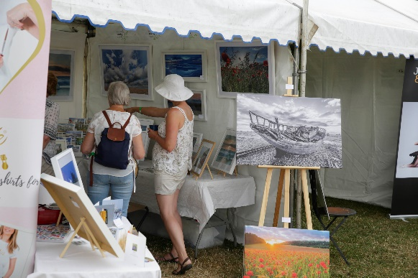
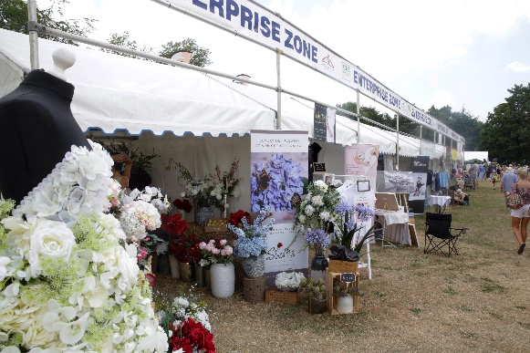
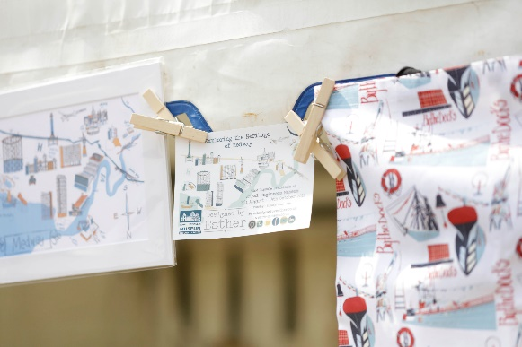

OFFICE USE ONLY | TRADESTAND NO: | GRID REF:  KENT COUNTY SHOW  10, 11, 12 JULY 2020 (FRI-SUN)  ENTERPRISE ZONE APPLICATION FORM | ACCEPTED? |  | DEADLINE:  06 APRIL 2020
Name and address to which all passes, correspondence etc. should be sent |  |  |  | Name and address of firm or organisation  (For inclusion in Show Catalogue, if successful)
Company..........................................................................................................  Address…..........................................................................................................  .........................................................................................................................  Post Code........................................................................................................  Tel no. / Mobile: …………………………………………………………………………………….……  On-Site Mobile Number ………………………………………………………………………….....  Email……………………………………………………………………………………………………………  Website: ……………………………………………………………………………………………………..  Contact Name.................................................................................................. |  |  |  | Company.................................................................................................  Address…................................................................................................  ................................................................................................................  ……………………………………………………………………………………………………………  Post Code................................................................................................  Tel no. / Mobile: …………………………………………………………………………………  Email…………………………………………………………………………………………………..  Website: …………………………………………………………………………………………….  Contact Name.........................................................................................
Please provide an overview of your business and the product/service you would like to promote at the Kent County Show?
When did you launch your business?
Why did you decide to set up your own business?

Have you ever owned a business before or set up any other businesses? Yes/No
If yes, please provide a brief description of the business.

Tell us why you would like to exhibit at the Kent County Show and how you feel this will benefit your business?
With on average 400 stands exhibiting at the Kent County Show please tell us how you would make your exhibit stand out and what you will be doing on your stand?
How do you currently promote your business? Do you have any social media accounts?

If successful your business details will be published in the Show Guide and relevant Show publications. Please provide up to a maximum of 25 words describing your exhibit to be included in the catalogue.

Finally, please use the space below to provide us with any further information you feel would support your application. Please include photos and additional documentation which you feel would supplement your application.

I/WE hereby apply for a pitch in the Enterprise Zone and agree to abide by the terms and conditions for this section of the Show and as set out in the tradestand brochure (please download a copy via the Showground website).
Signature……………………………………………………………………….Print Name:………………………………………………………………………………...
Status:………..…..……………………………………………………………Date:……….……………………………………………………………………………………

Application forms must be completed and returned to The Tradestand Department,
Kent County Agricultural Society, Kent Showground, Detling, Maidstone, Kent ME14 3JF.
Email: rosie@kentshowground.co.uk Web: www.kentshowground.co.uk Tel: 01622 633051
DEADLINE DATE: 06 APRIL 2020

