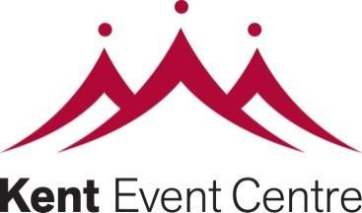
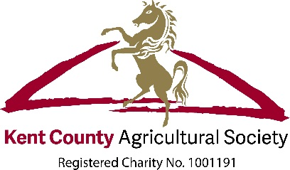

Maidstone Exhibition Hall

Join the supporters and friends of the Kent County Agricultural Society
by purchasing a named brick on our sponsors’ wall.

We are offering all our members the chance to buy your very own named brick for £100 (including VAT). Each brick will be professionally engraved with your name or names and will become your permanent legacy to the Maidstone Exhibition Hall at the Kent Showground.

To purchase a brick please complete the form below and return it with full payment to: info@kentshowground.co.uk or the Show Office, Kent County Agricultural Society, Kent Showground, Detling, Maidstone, Kent ME14 3JF.

I would like to purchase a brick(s) to support future projects at the Kent Showground.
Name
Address
Postcode Email
Tel

Please find enclosed a cheque for £100 per brick made payable to the Kent County Agricultural Society.

Alternatively please charge £100 to my Mastercard Visa Switch
Card Number Security Code
Start Date End Date Switch Issue Number
Please write your inscription using the grid below. Each line represents a line of text with up to 16 characters. Space and punctuations count as characters. You can use upper or lower case, whichever you prefer. There is no need to centre your text as the engraving process does this automatically.

Signed Date
Don’t forget Gift Aid
Please tick if you are a UK Taxpayer and are happy for us to claim Gift Aid on this donation.

This means for every £1 you give we get an extra 25 pence from HMRC, making your donation go further. In order for us to reclaim tax, you must pay income tax/capital gains tax at least equal to the tax that we will reclaim.

If you have any questions please contact the office on 01622 630975 email: info@kentshowground.co.uk
Terms and Conditions

- All bricks will measure 8” x 4”.
- All bricks will remain the sole property of KCAS.
- In their pursuit of correctness and uniformity, KCAS reserves the right to approve all lettering and ask for any unsuitable inscription to be amended.
- If, regrettably, KCAS has to refuse any application, there will be no obligation for KCAS to have to cite the reason.
- Every effort will be undertaken by KCAS to reproduce every inscription as set out on the order form. Amendments necessitated by an error on the part of KCAS, will be made free of charge. However, if the donor requests a change after the original order has been confirmed, then a reasonable amendment charge may be made.
- Orders will be handled on a first-come, first-served basis.
- Upon acceptance by KCAS all orders will become non-cancellable.
- Prices are inclusive of donation for the brick and the costs of engraving, delivery and installation.
- No refunds will be given by KCAS.
- It is envisaged that the bricks will be displayed in the building for its lifetime. In exceptional circumstances, KCAS reserves the right to move or relocate the bricks without liability.
- Although of excellent quality and designed to last, bricks may become worn or damaged over time owing to natural causes. No liability can be accepted for this by KCAS.
- Bricks are manufactured to British Standards specifications for size, dimensions, strength, shape, porosity, etc. Colour and texture can vary slightly due to batch processing techniques but such variances are subject to compliance with industrial tolerances.
- KCAS will have complete control over the location and installation date of the bricks.

